WEEK 4: ORDER MANAGEMENT SYSTEM

Aim
To create an Order Management System database and execute SQL queries for inserting, updating, deleting, joining, and summarising order-related data.

Database Structure
Database: OrderDB
- Customer(Customer_ID, Customer_Name, Email, City)
- Product(Product_ID, Product_Name, Price)
- Orders(Order_ID, Customer_ID, Order_Date, Total_Amount, Order_Status)
- Order_Details(Order_Detail_ID, Order_ID, Product_ID, Quantity, Price)

Operations Performed
- Created the database and four related tables.
- Added primary keys, foreign keys, and validation constraints.
- Inserted sample customer, product, order, and order-detail records.
- Updated order statuses, product quantity, and order total.
- Used DELETE, SELECT, JOIN, LEFT JOIN, GROUP BY, aggregate functions, and subqueries.

Query Outputs
The following screenshots show the result grids supplied for this SQL task.
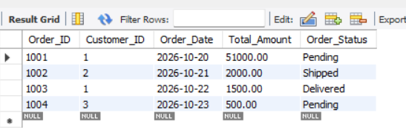
Output 1: Orders table

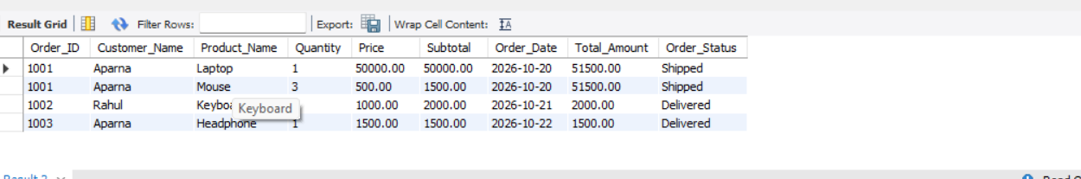
Output 2: Order details with customer and product

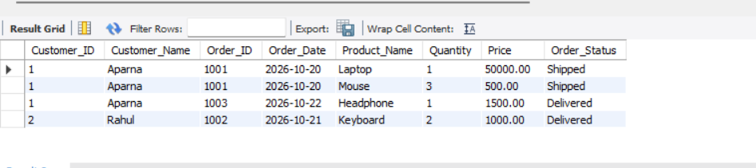
Output 3: Customer-wise order details

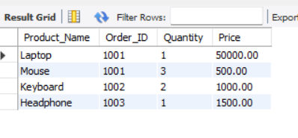
Output 4: Product order details

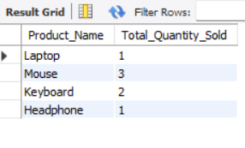
Output 5: Total quantity sold by product

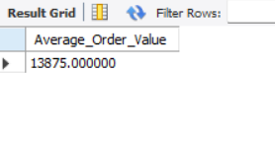
Output 6: Average order value

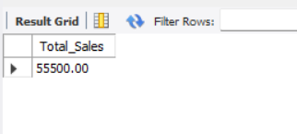
Output 7: Total sales

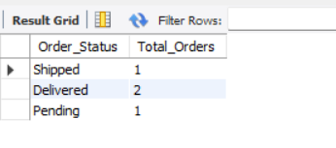
Output 8: Order status count

Result
The OrderDB database and its related tables were defined using SQL. The supplied outputs demonstrate order retrieval, customer and product joins, product quantity totals, average order value, total sales, and order-status counts.

SQL Program
CREATE DATABASE OrderDB;
USE OrderDB;
CREATE TABLE Customer (
Customer_ID INT PRIMARY KEY,
Customer_Name VARCHAR(50) NOT NULL,
Email VARCHAR(100) UNIQUE,
City VARCHAR(50)
);
CREATE TABLE Product (
Product_ID INT PRIMARY KEY,
Product_Name VARCHAR(50) NOT NULL,
Price DECIMAL(10,2) NOT NULL CHECK (Price > 0)
);
CREATE TABLE Orders (
Order_ID INT PRIMARY KEY,
Customer_ID INT NOT NULL,
Order_Date DATE NOT NULL,
Total_Amount DECIMAL(10,2) DEFAULT 0
CHECK (Total_Amount >= 0),
Order_Status VARCHAR(20) DEFAULT 'Pending'
CHECK (Order_Status IN
('Pending', 'Shipped', 'Delivered', 'Cancelled')),
FOREIGN KEY (Customer_ID)
REFERENCES Customer(Customer_ID)
);
CREATE TABLE Order_Details (
Order_Detail_ID INT PRIMARY KEY,
Order_ID INT NOT NULL,
Product_ID INT NOT NULL,
Quantity INT NOT NULL CHECK (Quantity > 0),
Price DECIMAL(10,2) NOT NULL CHECK (Price > 0),
FOREIGN KEY (Order_ID) REFERENCES Orders(Order_ID),
FOREIGN KEY (Product_ID) REFERENCES Product(Product_ID),
UNIQUE (Order_ID, Product_ID)
);
INSERT INTO Customer VALUES
(1, 'Aparna', 'aparna@gmail.com', 'Chennai'),
(2, 'Rahul', 'rahul@gmail.com', 'Delhi'),
(3, 'Priya', 'priya@gmail.com', 'Mumbai'),
(4, 'Kumar', 'kumar@gmail.com', 'Chennai');
INSERT INTO Product VALUES
(101, 'Laptop', 50000),
(102, 'Mouse', 500),
(103, 'Keyboard', 1000),
(104, 'Headphone', 1500);
INSERT INTO Orders VALUES
(1001, 1, '2026-10-20', 51000, 'Pending'),
(1002, 2, '2026-10-21', 2000, 'Shipped'),
(1003, 1, '2026-10-22', 1500, 'Delivered'),
(1004, 3, '2026-10-23', 500, 'Pending');
INSERT INTO Order_Details VALUES
(1, 1001, 101, 1, 50000),
(2, 1001, 102, 2, 500),
(3, 1002, 103, 2, 1000),
(4, 1003, 104, 1, 1500),
(5, 1004, 102, 1, 500);
SELECT * FROM Orders;
UPDATE Orders
SET Order_Status = 'Shipped'
WHERE Order_ID = 1001;
UPDATE Orders
SET Order_Status = 'Delivered'
WHERE Order_ID = 1002;
UPDATE Order_Details
SET Quantity = 3
WHERE Order_Detail_ID = 2;
UPDATE Orders
SET Total_Amount = (
SELECT SUM(Quantity * Price)
FROM Order_Details
WHERE Order_ID = 1001
)
WHERE Order_ID = 1001;
DELETE FROM Order_Details
WHERE Order_ID = 1004;
DELETE FROM Orders
WHERE Order_ID = 1004
AND Order_Status = 'Cancelled';
SELECT
o.Order_ID,
c.Customer_Name,
p.Product_Name,
od.Quantity,
od.Price,
(od.Quantity * od.Price) AS Subtotal,
o.Order_Date,
o.Total_Amount,
o.Order_Status
FROM Orders o
JOIN Customer c ON o.Customer_ID = c.Customer_ID
JOIN Order_Details od ON o.Order_ID = od.Order_ID
JOIN Product p ON od.Product_ID = p.Product_ID
ORDER BY o.Order_ID;
SELECT
c.Customer_ID,
c.Customer_Name,
o.Order_ID,
o.Order_Date,
p.Product_Name,
od.Quantity,
od.Price,
o.Order_Status
FROM Customer c
JOIN Orders o ON c.Customer_ID = o.Customer_ID
JOIN Order_Details od ON o.Order_ID = od.Order_ID
JOIN Product p ON od.Product_ID = p.Product_ID
ORDER BY c.Customer_ID, o.Order_Date;
SELECT
p.Product_Name,
o.Order_ID,
od.Quantity,
od.Price
FROM Product p
JOIN Order_Details od ON p.Product_ID = od.Product_ID
JOIN Orders o ON od.Order_ID = o.Order_ID;
SELECT
p.Product_Name,
COUNT(DISTINCT od.Order_ID) AS Times_Ordered
FROM Product p
LEFT JOIN Order_Details od ON p.Product_ID = od.Product_ID
GROUP BY p.Product_ID, p.Product_Name;
SELECT
p.Product_Name,
COALESCE(SUM(od.Quantity), 0) AS Total_Quantity_Sold
FROM Product p
LEFT JOIN Order_Details od ON p.Product_ID = od.Product_ID
GROUP BY p.Product_ID, p.Product_Name;
SELECT Customer_ID, Customer_Name, Order_Count
FROM (
SELECT
c.Customer_ID,
c.Customer_Name,
COUNT(o.Order_ID) AS Order_Count
FROM Customer c
JOIN Orders o ON c.Customer_ID = o.Customer_ID
GROUP BY c.Customer_ID, c.Customer_Name
) AS T
WHERE Order_Count = (
SELECT MAX(Order_Count)
FROM (
SELECT COUNT(*) AS Order_Count
FROM Orders
GROUP BY Customer_ID
) AS X
);
SELECT
c.Customer_Name,
COALESCE(SUM(o.Total_Amount), 0) AS Total_Spending
FROM Customer c
LEFT JOIN Orders o ON c.Customer_ID = o.Customer_ID
AND o.Order_Status <> 'Cancelled'
GROUP BY c.Customer_ID, c.Customer_Name;
SELECT AVG(Total_Amount) AS Average_Order_Value
FROM Orders
WHERE Order_Status <> 'Cancelled';
SELECT SUM(Total_Amount) AS Total_Sales
FROM Orders
WHERE Order_Status <> 'Cancelled';
SELECT Order_Status, COUNT(*) AS Total_Orders
FROM Orders
GROUP BY Order_Status;

